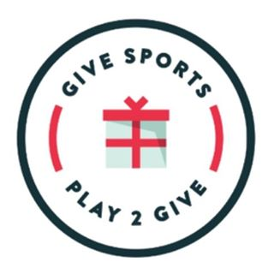
JOINT PRESS RELEASE

Boulder Bulls and GIVE SPORTS are excited to announce that the companies have merged to create GIVE NORTH. Job Brown and staff have done a tremendous job building a competitive program in the Boulder area.
Both Boulder Bulls and GIVE SPORTS are committed to providing the highest quality of basketball instruction to all of the communities in our areas. The merger of the two programs will increase opportunities regionally and nationally. GIVE NORTH will also be able to collaborate with GIVE DENVER and GIVE SPRINGS to create highly competitive travel teams that will compete on exclusive and elite circuits.
Job Brown and Xavier Silas, owner of GIVE SPORTS, are dedicated to working diligently to develop young players north of Denver.
GIVE SPORTS features the following program attributes:
- Four different grade levels are ranked in the Mountain West and on the West Coast.
- Our coaching staff has over 45 years of collegiate basketball playing experience and over 30 years of professional playing experience.
- All participants are required to participate in monthly charitable activities. We will always PLAY TO GIVE.
- Each grade offers a local competitive team and a travel competitive team that plays locally and out of state.
- Class of 2027, 2026, 2025, 2024 and 2023 will play on Under Armour Future Is Now Circuit.
- Class of 2022 will compete in an east coast tour visiting cities like New York, Philadelphia, and Washington D.C.
- Class of 2021 and 2022 have been selected as premier teams in the Hoop Group Showcase League. As a premier team, each class is guaranteed to play on the main court in big showcase tournaments along the eastern seaboard. Last year this circuit had 300+ Division I college coaches in attendance.
Job Brown and Xavier Silas are available to answer any questions you may have. We look forward to this upcoming season and thank you for the support of our new partnership.

